Breathing and exercise instructions at home after COVID-19 infection

Increasing exercise

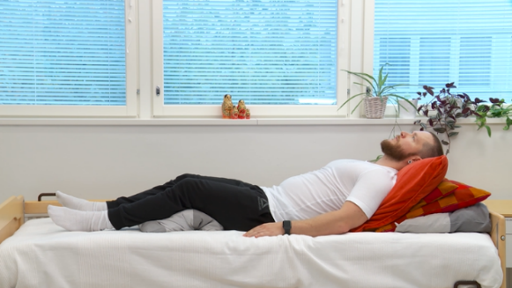
- A lung infection reduces your oxygen intake, and thereby your functional capacity as well. Bed rest may also weaken your general condition and muscle strength. Avoid excessive bed rest: try instead resting in a half-sitting position at about 30 to 60 degrees angle. It is also easier to breathe in a half-sitting position.

- Try to get up regularly and take breaks from sitting still. For the first rehabilitation exercises, it is usually enough to just move about at home and perform light chores.

- As your recovery progresses, you can start to gradually increase the strain. For example, if you used to pedal an exercise bike, start by pedalling short periods with light resistance, and gradually increase the duration, and only then you may increase the resistance.

- If your isolation is over and you may leave the house, then walking and Nordic walking are great forms of exercise. First increase the number of walks, then the distance, and finally the speed.

- Avoid heavy physical strain as long as you have symptoms.

Breathing exercises

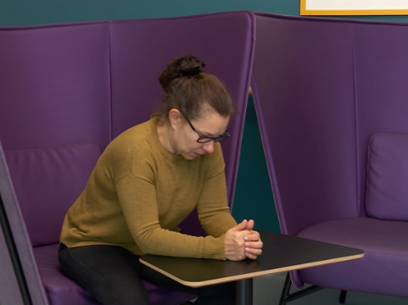
- After the illness, your breathing may feel heavy and you may experience excess mucous in the lungs. The coachman position helps to calm and deepen your breathing, and it also increases pulmonary ventilation.

- Slow down your breathing by calmly inhaling through your nose. Keep your shoulders relaxed. Let the exhaled air pass through your pursed lips on its own.

- Deepen your breathing, and you may hold your hand on your upper abdomen at the same time to feel the movement in your diaphragm: your hand will rise during inhale and lower during exhale.
- Practice good coughing hygiene: cough into a tissue and away from others. Enhanced breathing pushes phlegm out of the lungs.

- When you are able to move about as usual and breathing no longer feels difficult, the exercises are no longer necessary.

Always follow any individual instructions given to you. If you feel like you need more instructions for recovery, please contact your primary healthcare provider.

Please see instruction videos (in Finnish) in Kuntoutumistalo in Terveyskylä:
Ajurinasento - The coachman position
KUNTOUTUMISTALO.FI > Kuntoutujalle > Hengitykseen liittyvät ongelmat > Opas hengityksen harjoitteluun > Asennot hengityksen helpottamiseksi >Ajurin asento
Puoli-istuva-asento - Half-sitting position
KUNTOUTUMISTALO.FI > Kuntoutujalle > Hengitykseen liittyvät ongelmat > Opas hengityksen harjoitteluun > Asennot hengityksen helpottamiseksi > Puoli-istuva asento
Huulirakohengitys - Pursed lip breathing
KUNTOUTUMISTALO.FI > Kuntoutujalle > Hengitykseen liittyvät ongelmat > Opas hengityksen harjoitteluun > Tekniikat hengityksen harjoittamiseksi > Huulirakohengitys
Palleahengitys - Diaphragmatic breathing
KUNTOUTUMISTALO.FI > Kuntoutujalle > Hengitykseen liittyvät ongelmat > Opas hengityksen harjoitteluun > Tekniikat hengityksen harjoittamiseksi > Syvä palleahengitys

Patient instructions | HUS Internal Medicine and Rehabilitation, Physiotherapy | Approved on: 24 April 2020 | Approved by Jari Arokoski

